Year 10 – Formula Sheet

Number and Algebra

Index Laws: For any numerical value $a≠0$ and integers m and n
$a^{m}×a^{n}=a^{m+n}$ $a^{m}÷a^{n}=a^{m-n}$
${\left(a^{m}\right)}^{n}=a^{mn}$ $a^{m}b^{m}={(ab)}^{m}$

$\frac{1}{a^{m}}=a^{-m}$ $a^{0}=1$

For $a>0$and $m$ an integer and $n$ a positive integer, $a^{\frac{m}{n}}=\sqrt[n]{a^{m}}={(\sqrt[n]{a})}^{m}$

Logarithms: For $a, b, y, m$ and $n$ positive real and $k$ real

$1=a^{0}⟺\log_{a}{1}=0 y=a^{x}⇔\log_{a}{y}=x$ $$\log_{b}{x}=\frac{\log_{c}{x}}{\log_{c}{b}}$$

$$\log_{a}{m}+\log_{a}{n}= \log_{a}{mn} a=a^{1}⇔\log_{a}{a}=1$$

$\log_{e}{x=\ln{x}}$ $\log_{a}{{(m}^{k})=k\log_{a}{m}}$

Money and Financial Mathematics

For the principal ($P)$, Annual rate of interest$(r)$,and number of year $(t)$,

Simple Interest: I = Prt,

Compound Interest: $A=P{(1+r)}^{t}$ compounded annually

$A=P{(1+\frac{r}{n})}^{nt}$ compounded $n$ times a year

Measurement and Geometry

Pythagoras’ Theorem:
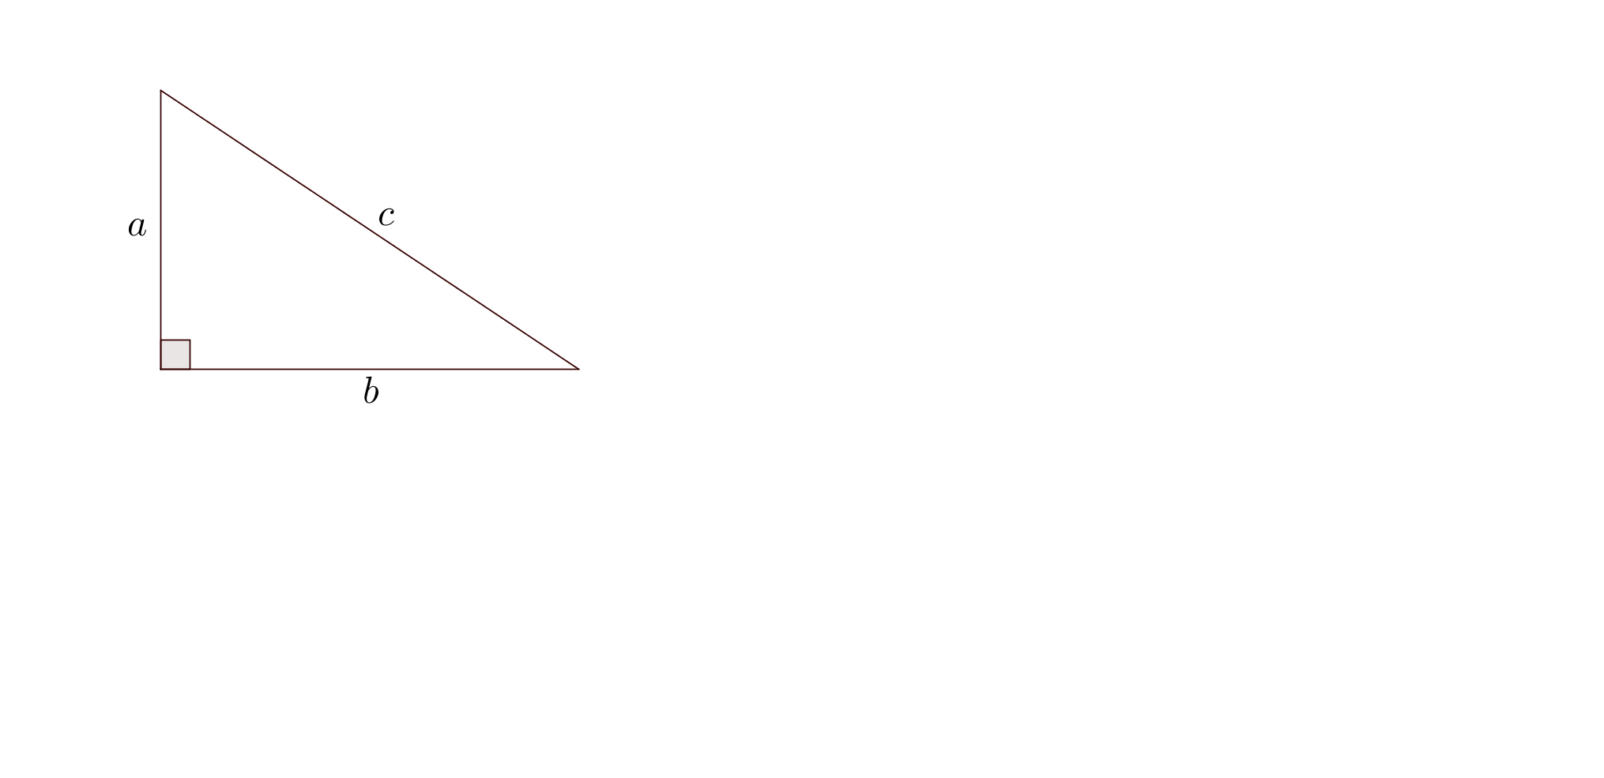
$$a^{2}+b^{2}=c^{2}$$

Trigonometric ratios:

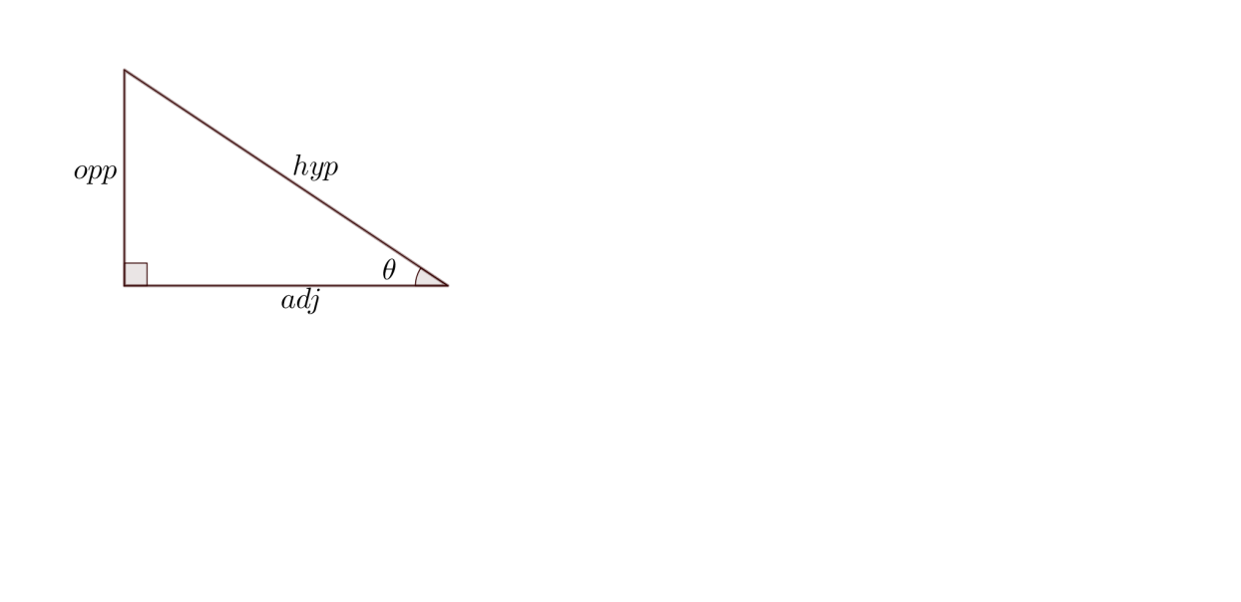
$\sin{θ= \frac{opposite}{hypotenuse}}$ $\cos{θ=\frac{adjacent}{hypotenuse}}$

$$\tan{θ=\frac{opposite}{adjacent}}$$

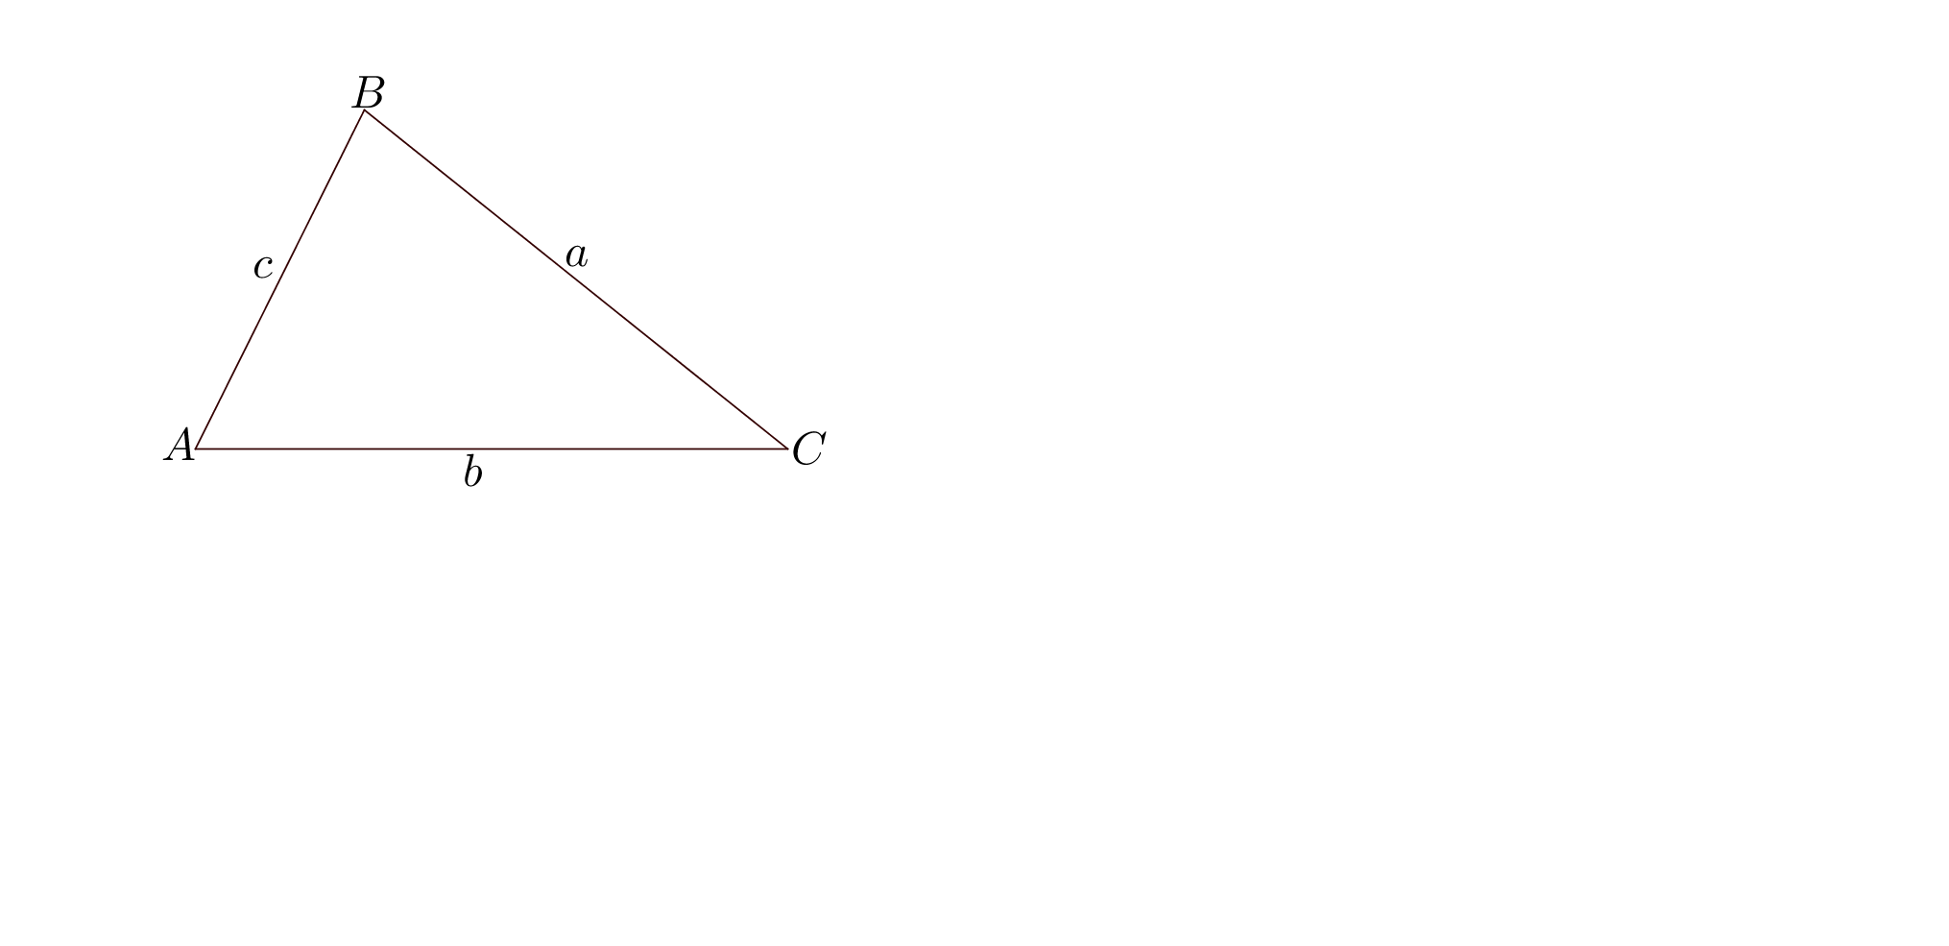
Area of$△ABC=\frac{1}{2}ab\sin{C}$

Sine Rule: $\frac{a}{\sin{A}}=\frac{b}{\sin{B}}=\frac{c}{\sin{C}}$

Cosine Rule: ${ a}^{2}=b^{2}+c^{2}-2bc\cos{A}$

Measurement and Geometry

Gradient of a line, m, through the points ($x$₁ ,$y$₁) and ($x$₂ ,$y$₂) is given by m = $\frac{rise}{run}=\frac{y_{2}-y_{1}}{x_{2}-x_{1}}$

Distance d, between the points ($x$₁ ,$y$₁) and ($x$₂ ,$y$₂) is given by $d=\sqrt{{(y_{2}-y_{1})}^{2}+{(x_{2}-x)}^{2}}$

Circumference of a circle: $C=2πr$ $= πd$, where r is the radius and d is the diameter

Area:
Triangle A = $\frac{1}{2}bh$ where$b$ is the base and $h$ is the height

Rectangle $A=lw$ where l is the length and $w$ is the width

Parallelogram $A=bh$

Rhombus or Kite $A=\frac{1}{2}xy$ where $x$ and $y$ are the lengths of the diagonals

Trapezium $A=\frac{1}{2}\left(a+b\right)h$ where $a$ and $b$ are the lengths of the parallel sides
Circle $A=πr^{2}$

Sector where is the angle size of the sector
Volume:
Prism $V=Ah$ where A is the area of the cross-section

Pyramid $V=\frac{1}{3}Ah$

Cone $V=\frac{1}{3}πr^{2}h$

Cylinder $V=πr^{2}h$

Sphere $V=\frac{4}{3}πr^{3}$

Total Surface Area:
Cylinder $S=2πr^{2}+2πrh$ where $S$ is the total surface area

Cone $S=πr(r+s)$ where $s$ is the slant height

Sphere $S=4πr^{2}$

Statistics and Probability

Probability: For any event A and its compliment $\overline{A}$
P(A) + P($\overline{A}$) = 1

